WriteAway Tutor Collision Avoidance – Messaging via Internal Notes

If you notice another tutor pick up a submission that you are working on, you can send an internal note to alert the tutor.

When you are working with a submission, be aware of incoming messages from your tutor colleagues:
- keep the browser with the submission information open where you can see it
- have your email open OR
- enable email notifications to watch for any messages from tutors


Here is an example where there are two tutors:


WriteAway Coordinator
WriteAway Tutor

Both tutors pick up the same submission, but only one tutor should be working on a reply to the student.

Follow the steps below to learn how tutors can alert one another:

WriteAway Tutor

“WriteAway Tutor” picks up a submission – the green bar at the top and the grey information box show that “WriteAway Tutor” has claimed the submission.


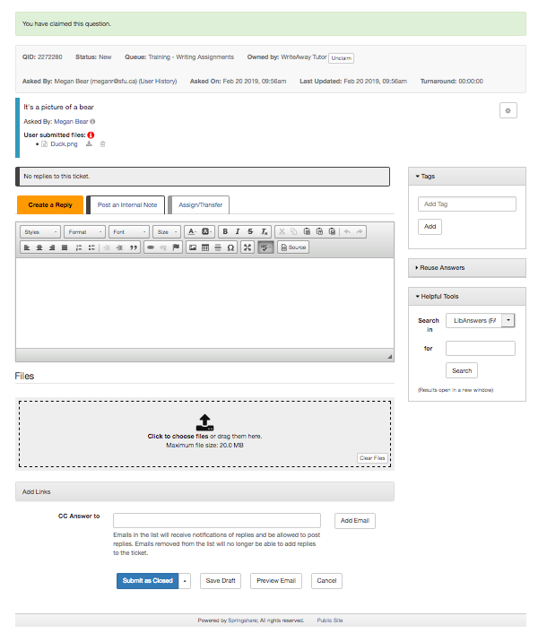
WriteAway Tutor
View

While “WriteAway Tutor” is working on the submission, another tutor “WriteAway Coordinator” picks up the same submission. We can see “WriteAway Coordinator” has picked up the ticket because of the blue box in the lower right-hand corner of the browser.

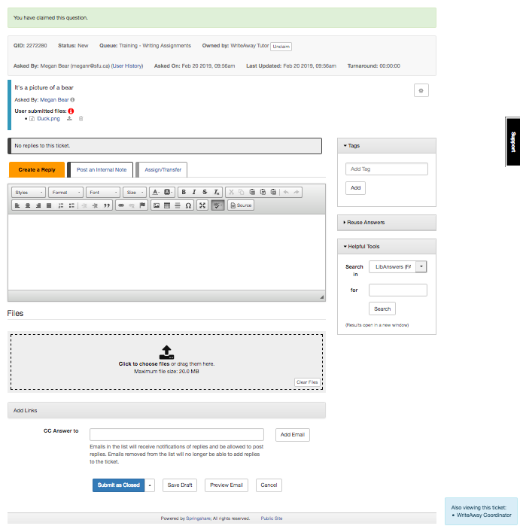
WriteAway Tutor
View

When “WriteAway Coordinator” picks up this submission, they will see the red bar at the top of the submission AND the blue box at the bottom right corner of the browser.
WriteAway Coordinator


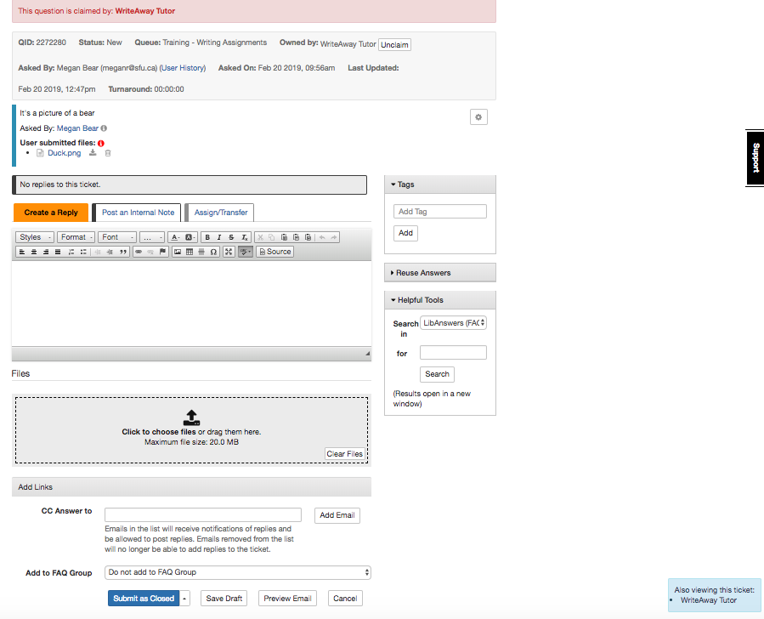
WriteAway Coordinator
View

WriteAway Tutor

“WriteAway Tutor” can send a message to “WriteAway Coordinator” by selecting “Post an Internal Note.”
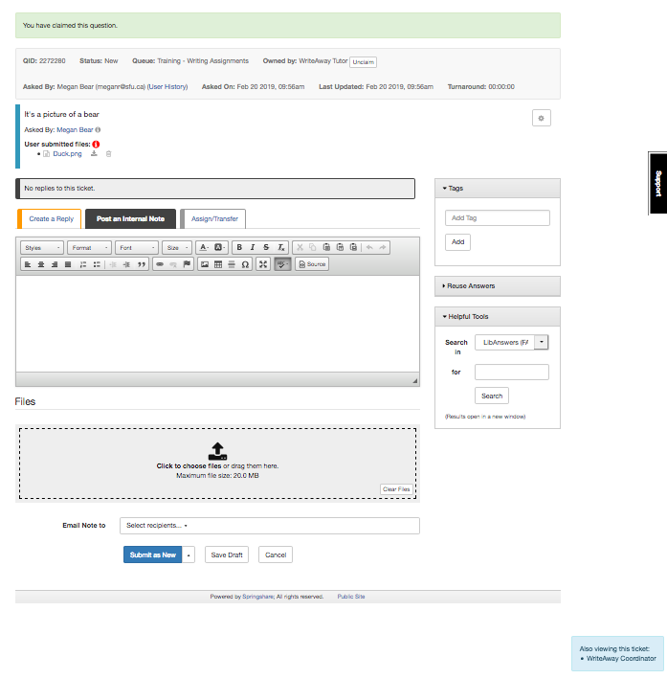
WriteAway Tutor
View

“WriteAway Tutor” types their message – they can say something like:

“Hi [TUTOR] I’m already working on this submission Head back to the dashboard and pick up the next submission in the queue.”
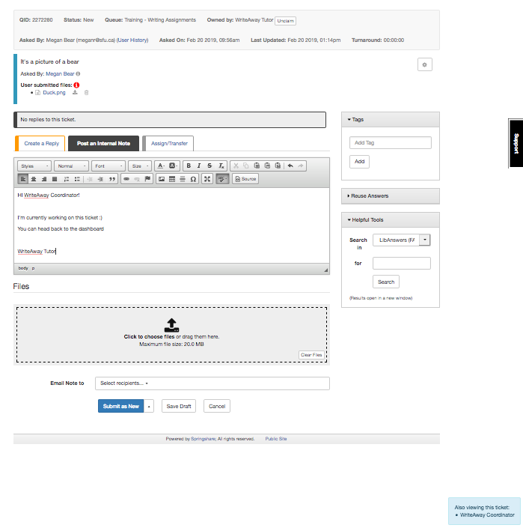
WriteAway Tutor
View

Once “WriteAway Tutor” has typed their message, they select the tutor who is also viewing the ticket from the drop down “Email Note to” menu.

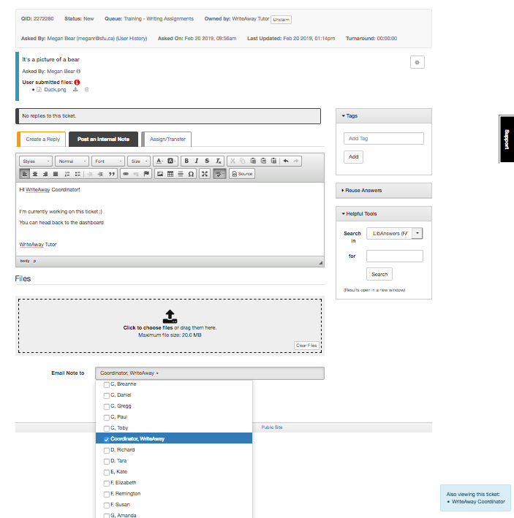
WriteAway Tutor
View

**Make sure that the Internal Note is only sent to the other tutor viewing the submission – there should only be one name selected in the “Email Note to” field**

Then “WriteAway Tutor” selects “Submit as New” to send the message (or “Submit as Open” if it is a second or third submission):

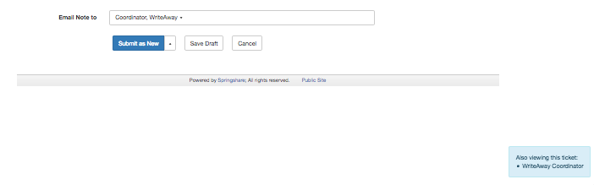

When the message is sent, a note is attached to the submission.
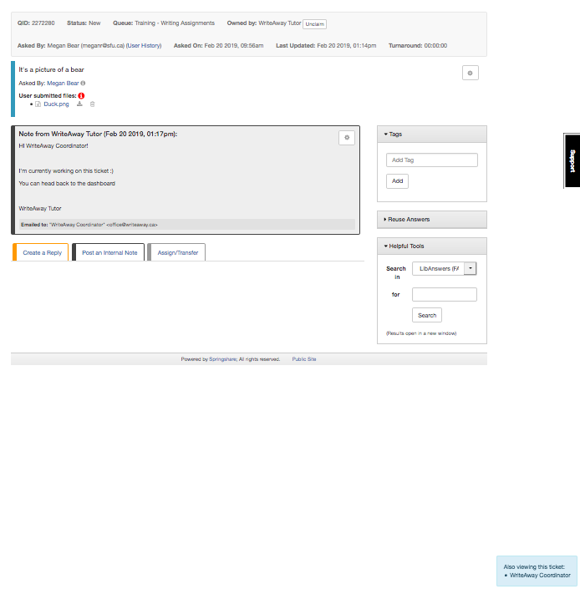
WriteAway Tutor
View
The note immediately appears on the other tutor’s browser.

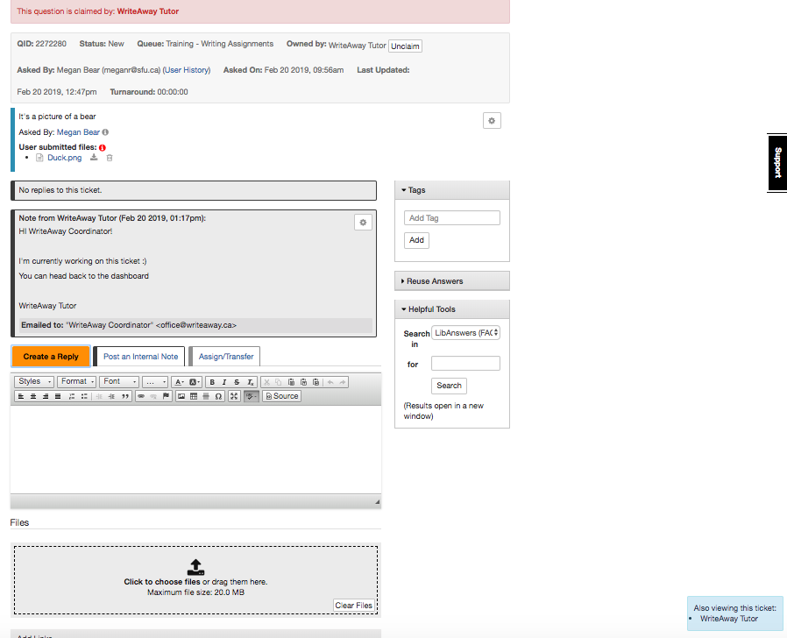
WriteAway Coordinator
View

The other tutor (“WriteAway Coordinator”) will also receive an email:

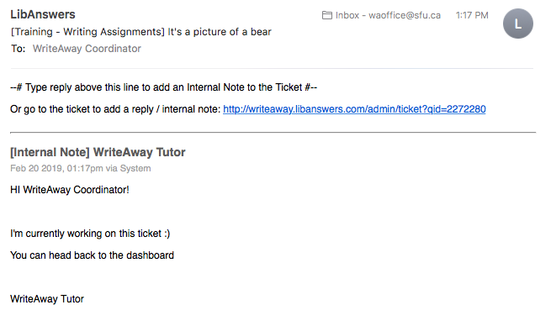
WriteAway Coordinator
View

Now that “WriteAway Coordinator” knows “WriteAway Tutor” is working on the submission, “WriteAway Coordinator” can return to the dashboard
When “WriteAway Coordinator” returns to the dashboard, “WriteAway Tutor” will be the only tutor working on the submission. “WriteAway Tutor” can switch back to the “Create a Reply” tab to respond to the student.

Before “WriteAway Tutor” replies to the student, they should save their draft and preview the email (as outlined in “Responding to Submissions”) to ensure that their feedback is ready for the student.

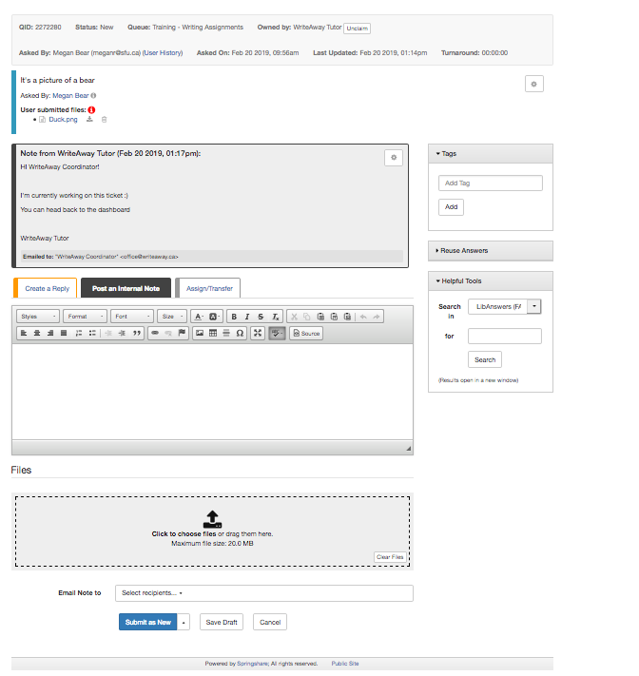
WriteAway Tutor
View

